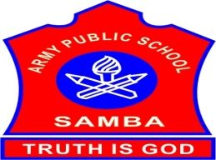
ARMY PUBLIC SCHOOL SAMBA
SCHOOL REPORT
OCTOBER 16,2023 - OCTOBER 31,2023

SCHOOL EVENTS

SUBROTO INTERNATIONAL FOOTBALL TOURNAMENT (U-17 BOYS) (OCTOBER 14-18,2023)
Subroto International Football Tournament was organized by Indian Airforce School,New Delhi from October 14-18,2023.Total 38 teams participated in this tournament at Dr Ambedkar Stadium,New Delhi.In this tournament Football team of APS Samba represented J&K team.
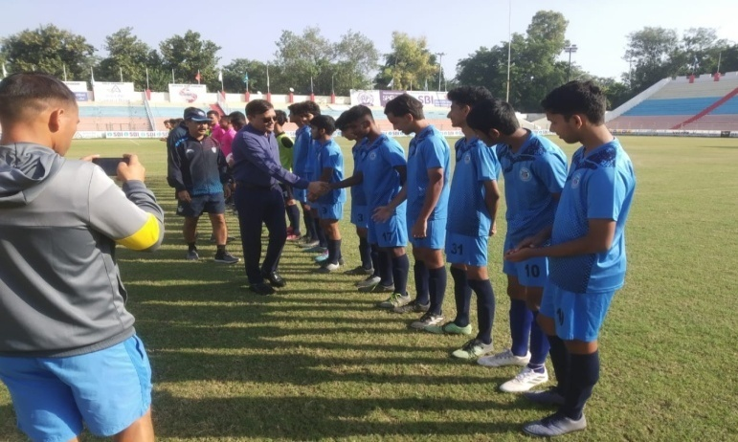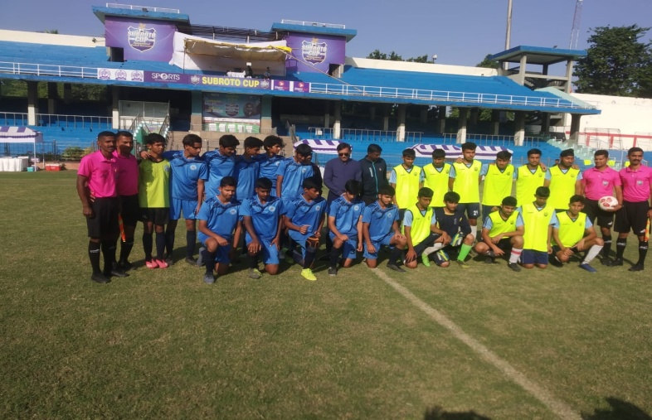
KIDS STAGE PLAY- SHRI RAM GATHA (OCTOBER 16-20,2023)
To introduce students to the rich cultural heritage of the country and to help them develop an appreciation for their own traditions and values, ‘Shri Ram Gatha’ was organized for the students of APS Samba.It was staged by the children of classes I-V from October 16-20,2023 in the Primary block for 6 days. It allows students to connect with their roots and understand the cultural context of the stories.
Ram Gatha began with the story of Shravan Kumar and King Dashratha followed by Lord Rama’s exile for 14 years,Kewat and his wife,Sita’s abduction by King Ravana, killing Ravana and returning to Ayodhya.On the last day,the complete gatha was shown to the whole school.
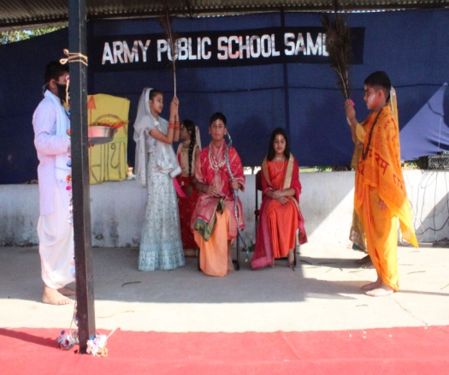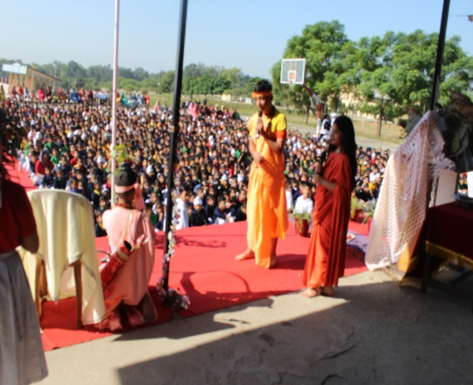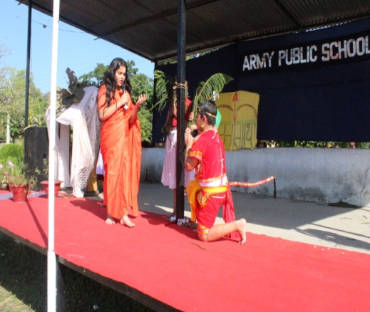
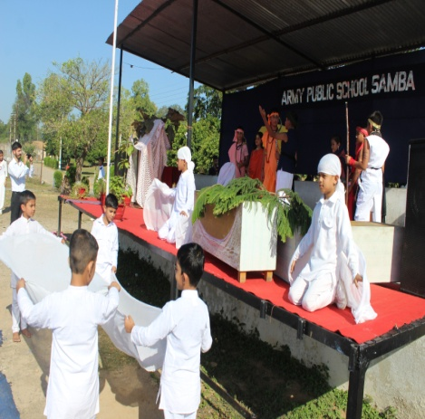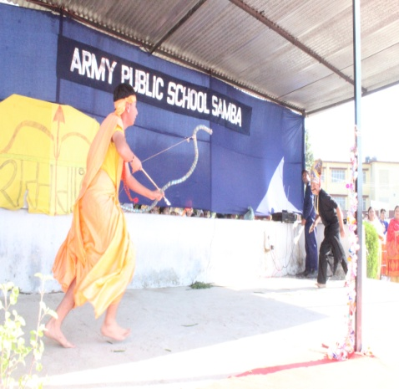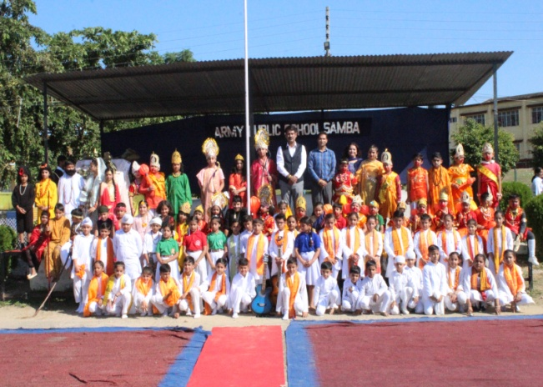
NCC DRILL PRACTICE AND CLASS ON MAP READING (OCTOBER 18,2023)
To help NCC cadets in the mass movement in an orderly manner from point to point, to inculcate a sense of discipline, smartness, alertness and to develop a quality of immediate response to the orders, a drill practice was given to the NCC Girl cadets by Sub Sonam on October 18,2023 at APS Samba. Class on ‘MAP READING’ was also conducted for the NCC cadets.
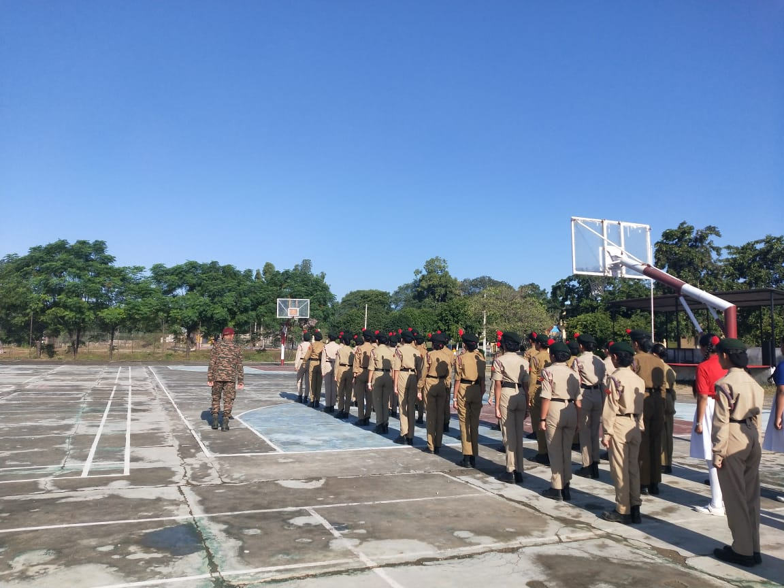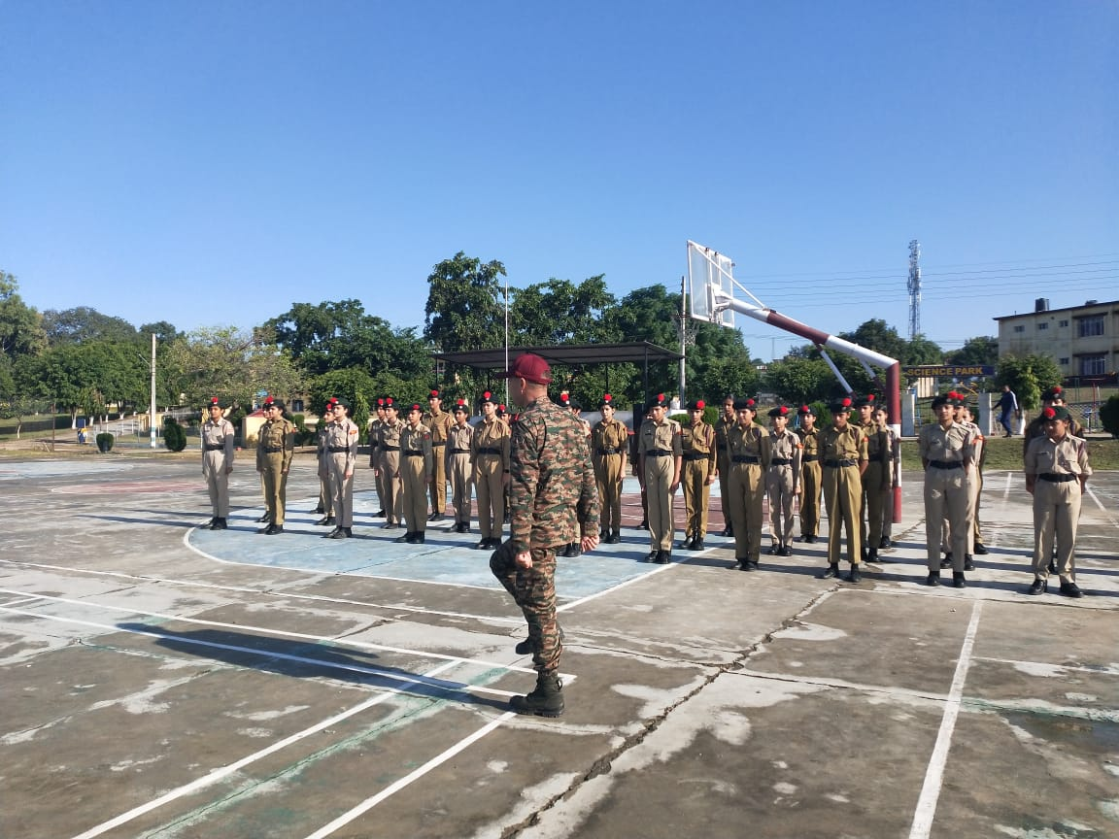
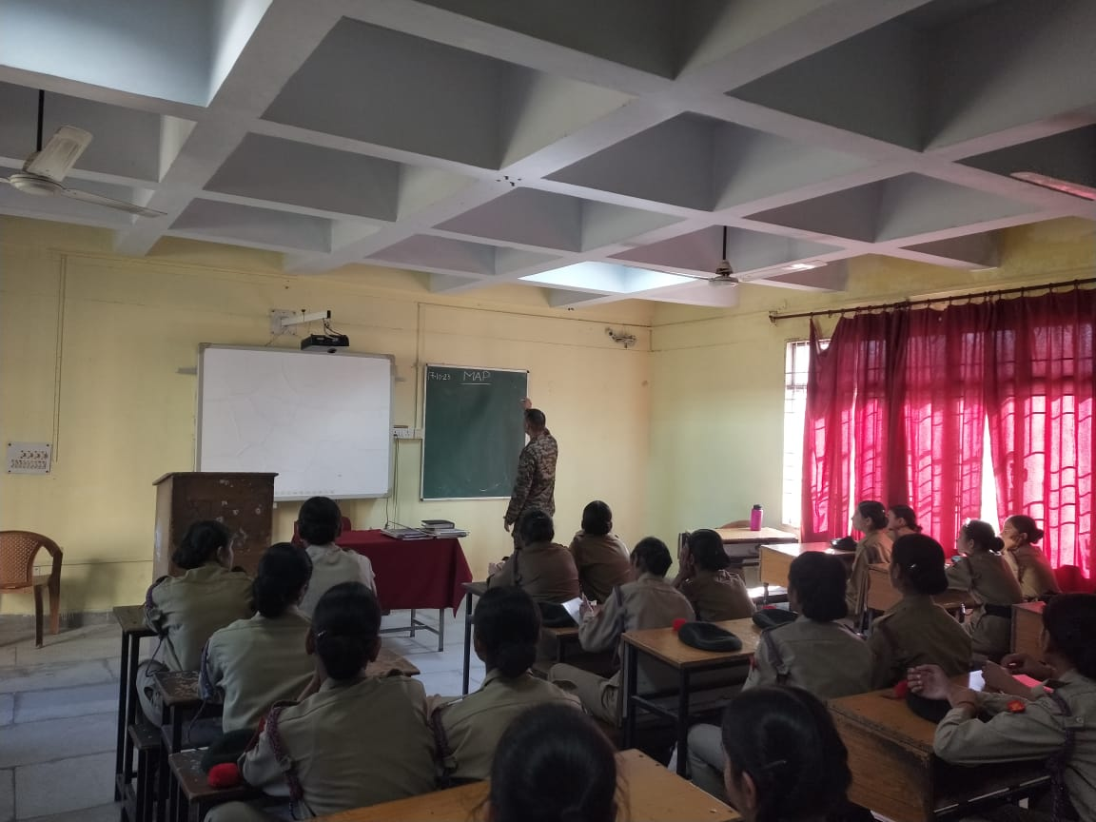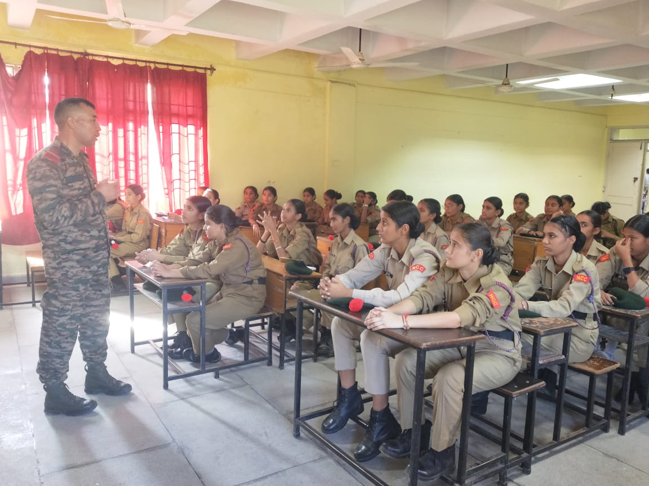
PRIZE DISTRIBUTION FOR VARIOUS SPORTS EVENTS & NCC ( OCTOBER 18,2023)
A Prize distribution ceremony was organized in the morning assembly on October 18,2023 to felicitate students who had participated in various sports events like Basketball,Volleyball etc and NCC cadets who had passed ‘A’ certificate exam with flying colours. The school honoured all its achievers for having attained a sterling record not only in scholastic but also co-scholastic domain.
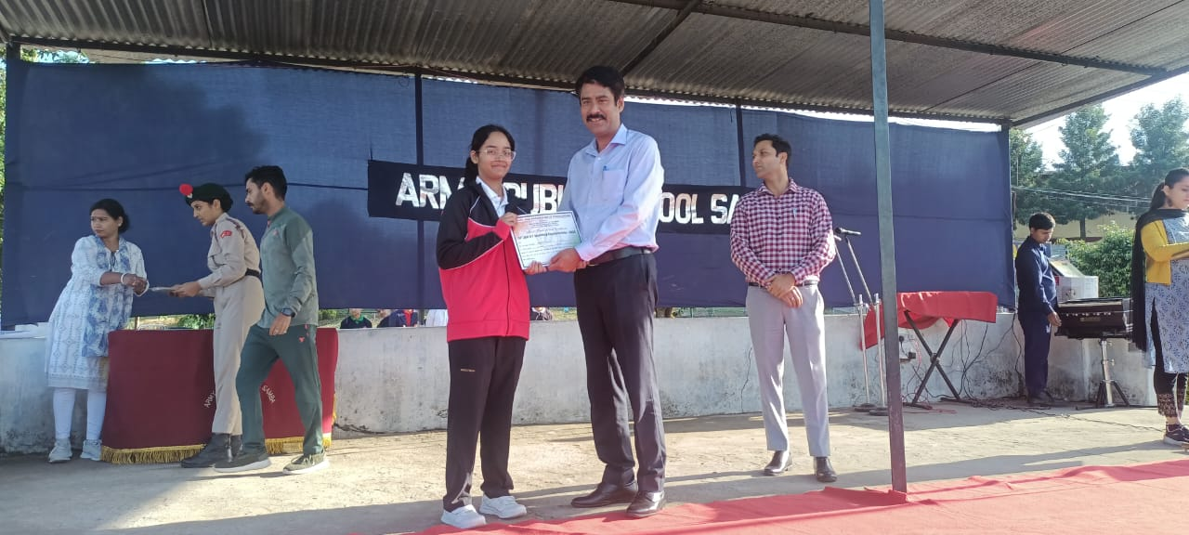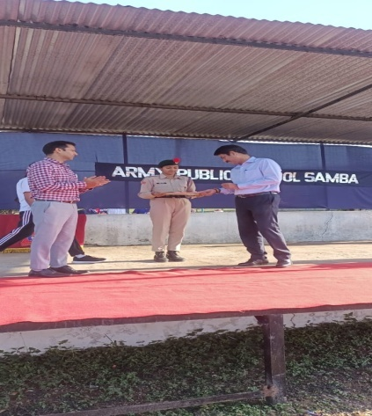
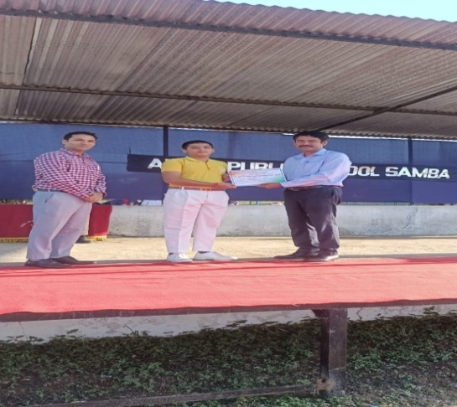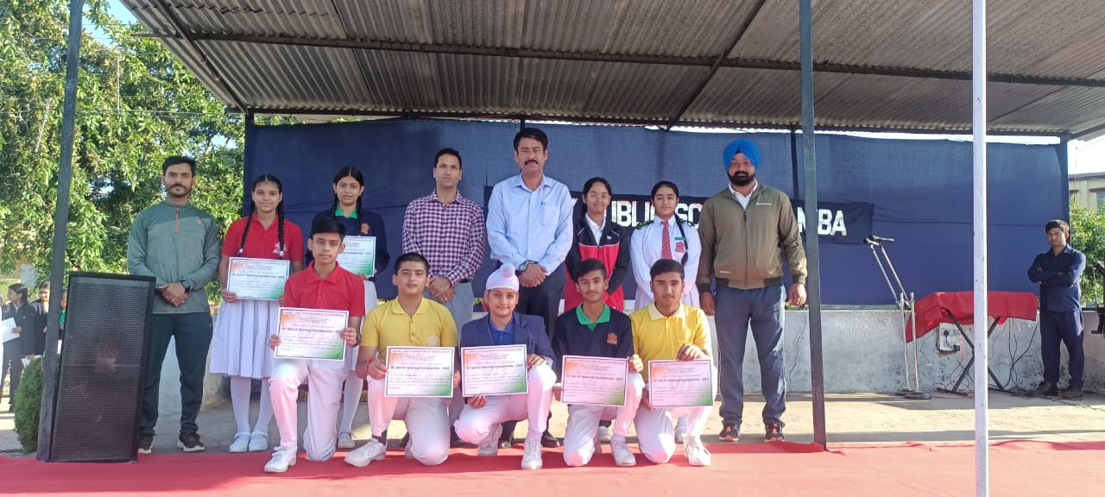
NIAS-ALC SESSION( OCTOBER 18,2023)
Session of NIAS- ALC was conducted on October 18,2023.The topic of discussion for the class was- “Nuclear Power Plants And Effects of Electric Currents”. Class was fully interactive and students took part in the discussion with great interest.
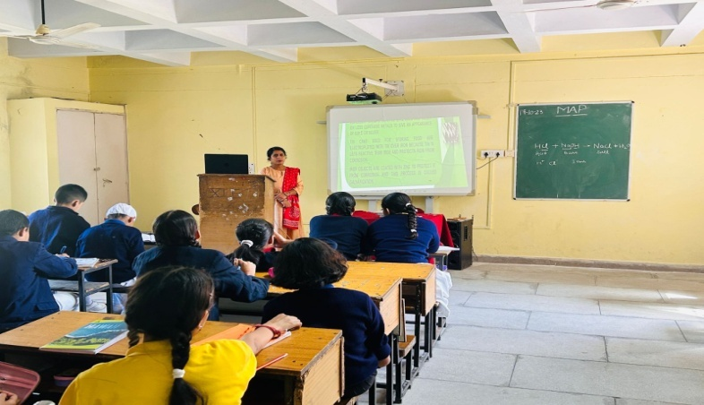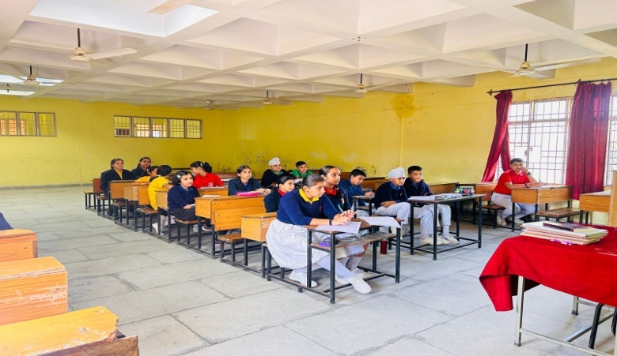

TWO DAYS’ YOGA SESSION ON MENSTRUAL HYGIENE FOR GIRLS (OCTOBER 18-19,2023)
To provide essential information and create awareness regarding menstrual hygiene among girls, a two days’ yoga session was organized for the girl students of class VI by the Yoga teacher, Ms Aradhana from October 18-19,2023 in the MP Hall of the School.
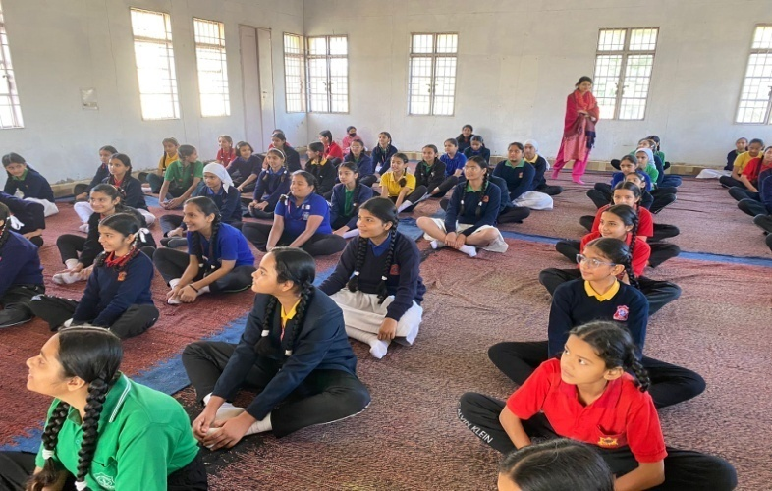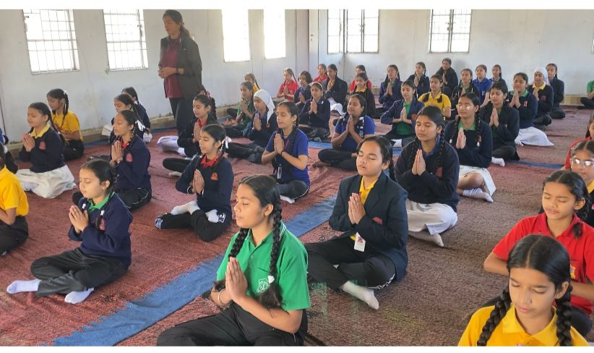

FELICITATION CEREMONY FOR ACADEMIC EXCELLENCE ( OCTOBER 19,2023)

A felicitation ceremony was organized in the morning assembly on October 19,2023 to felicitate students who have done exceedingly well in the Half Yearly exams. It was the time to applaud and reward the students for their sincere efforts during the Half Yearly Exams.The Principal,Mr Sanjeev Pradhan also motivated the winners to go ahead to achieve their heart’s desire –whatever that may be. He also reminded them to continue to uphold the values that are such an integral part of the institution. He appreciated the efforts put in by the students and the faculty for their
Overall performances and wished for them to come through with flying colours in future too.

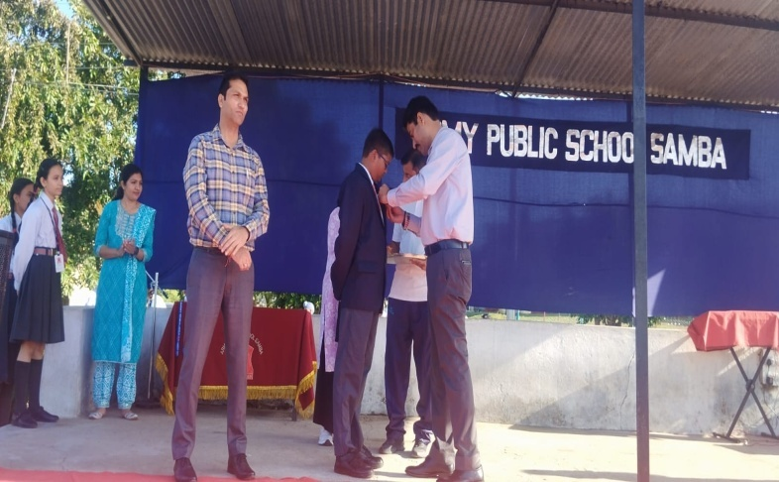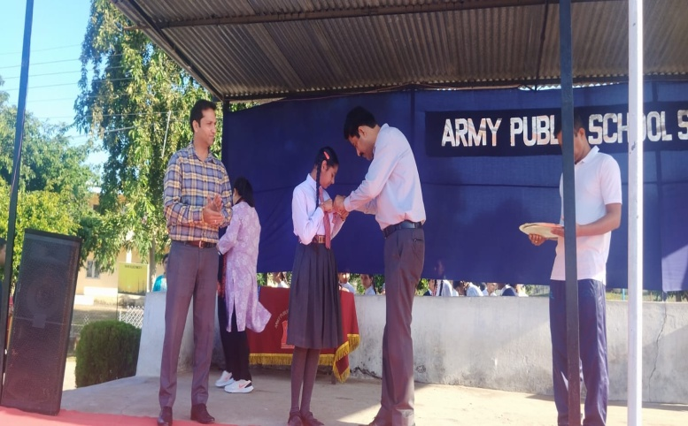

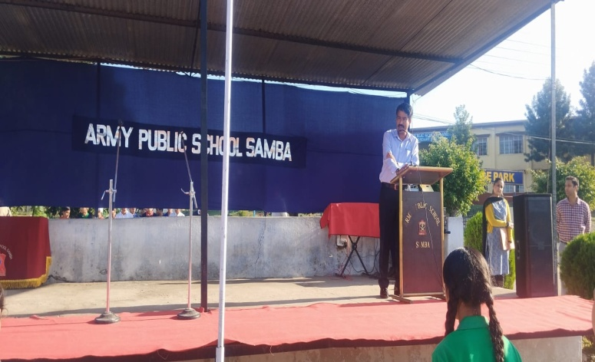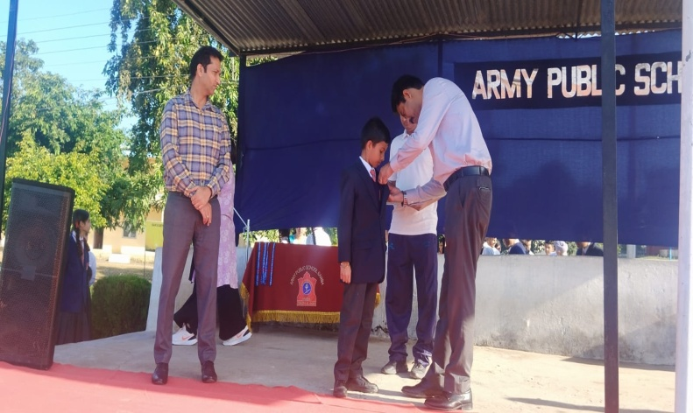

INTER SCHOOL BADMINTON COMPETITION FOR U-17 BOYS (OCTOBER 19-20,2023)
An Inter school Badminton competition for U-17 Boys organized by Sahodya CBSE Schools Complex was held at Sai International School, Hiranagar on October 19-20,2023.Team of APS Samba also participated in this competition.Mrigna Jasrotia of class IX from APS Samba bagged bronze medal in badminton singles competition.
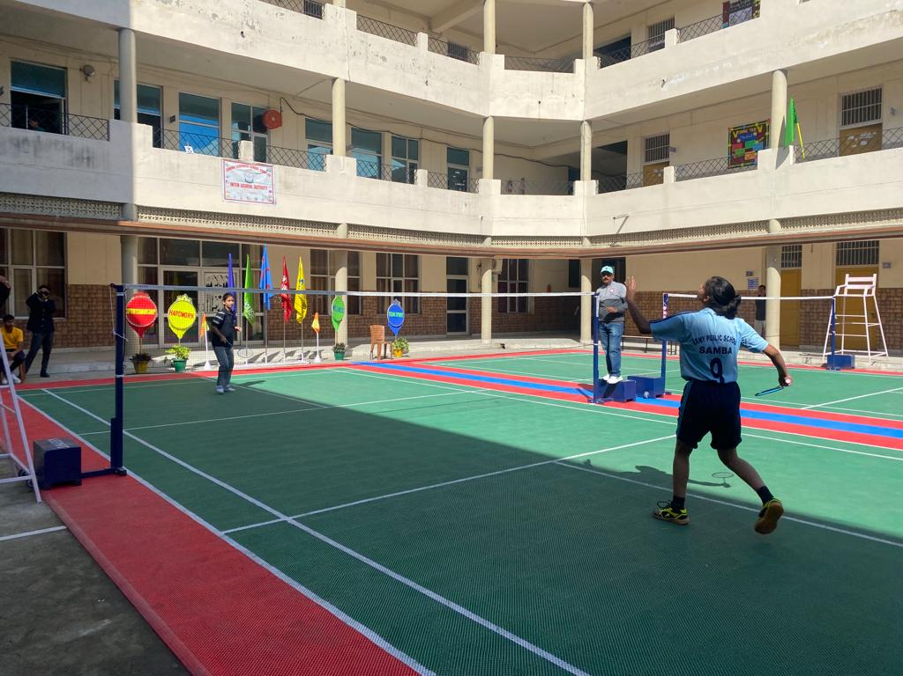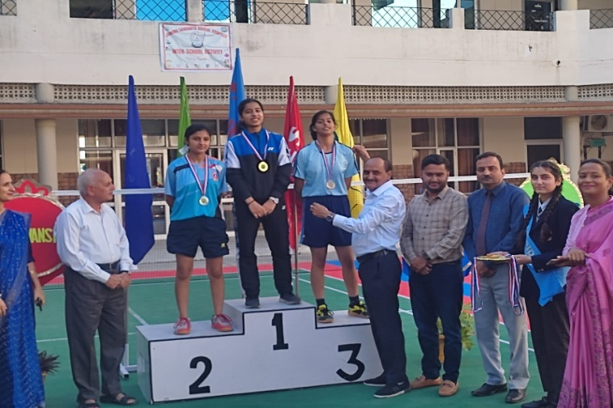

INTER DISTRICT DIVISION LEVEL TABLE TENNIS COMPETITION (OCTOBER 19-21,2023)
An Inter District Division Level Table Tennis Competition organized by Youth Services And Sports was held from October 19-21,2023 at Udhampur. Students from APS Samba also participated in this competition.
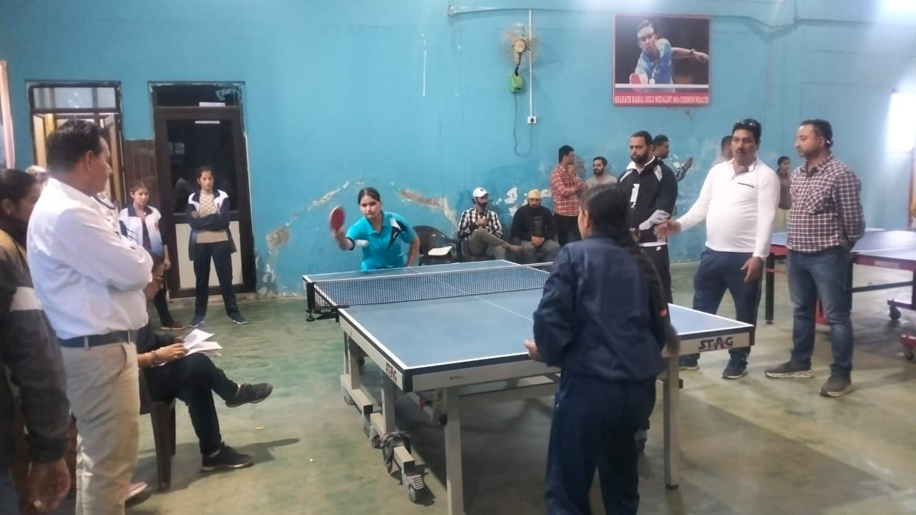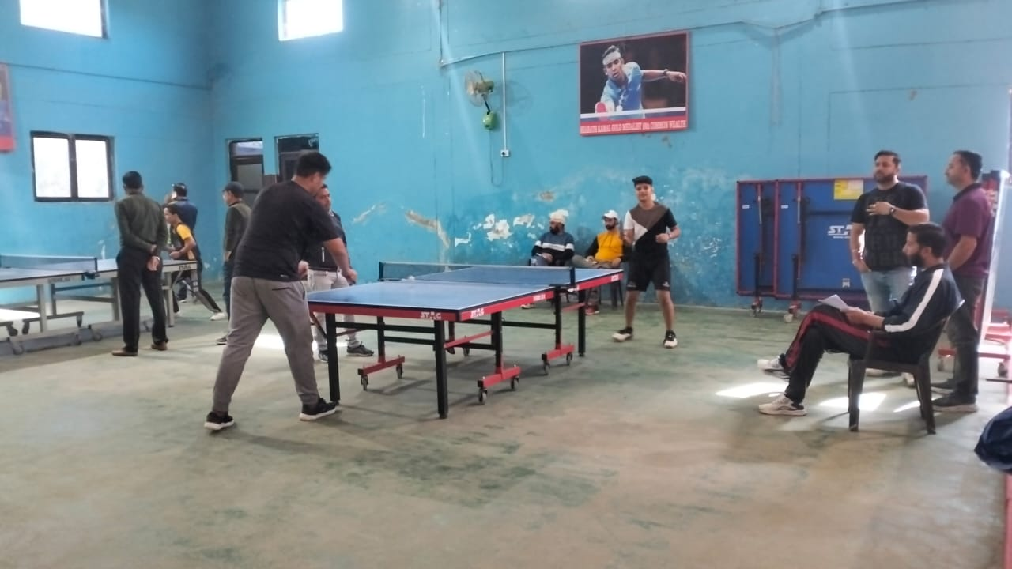

INTER HOUSE HINDI DEBATE COMPETITION(VI-VIII) (OCTOBER 20,2023)
To provide an excellent platform to the students to showcase their critical thinking, public speaking, and analytical skills, an Inter House Hindi Debate Competition for the students of classes VI-VIII was organized on October 20,2023.The topic for debate was “KYA ADHUNIK TAKNEEK MANAV SAMAJIK SAMPARK KO KHATAM KAR RAHI HAIN YA NAHI”.
The students expressed their opinions and ideas confidently and in a structured and organized manner. In this competition Trisha Soni from Gandhi House was adjudged as the best speaker,Snethia from Teresa House was adjudged as the best Interjector.Overall result of the competition is as:
Teresa House-First position,
Gandhi House - Second position
Nehru House - Third position.
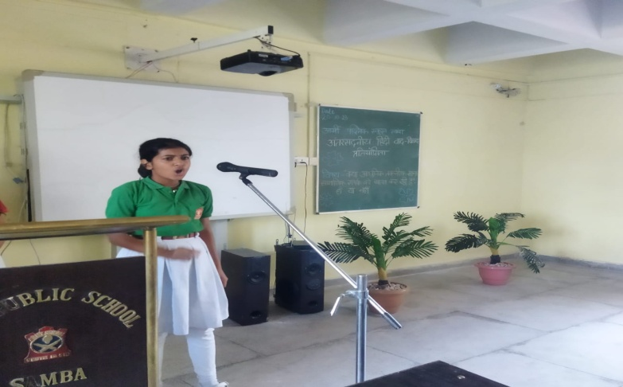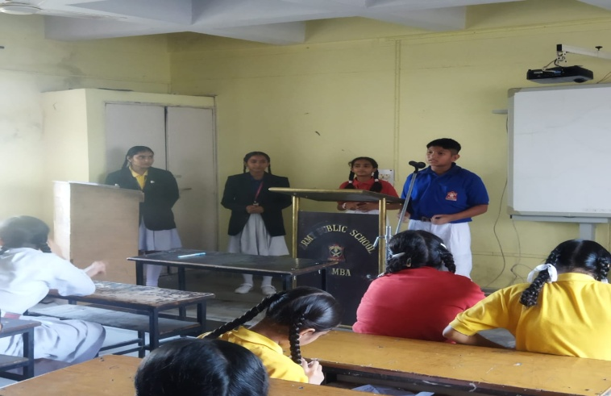
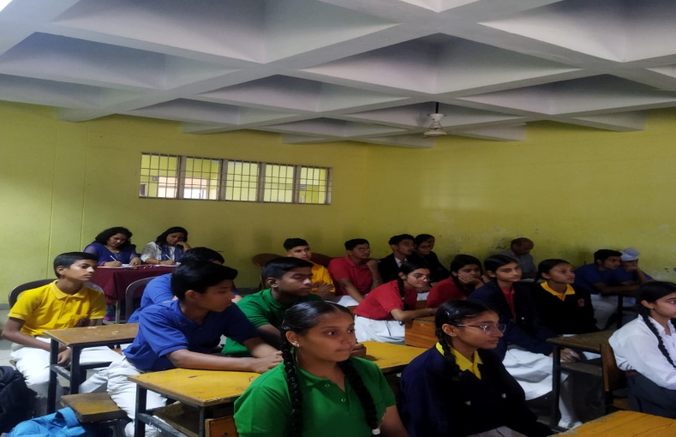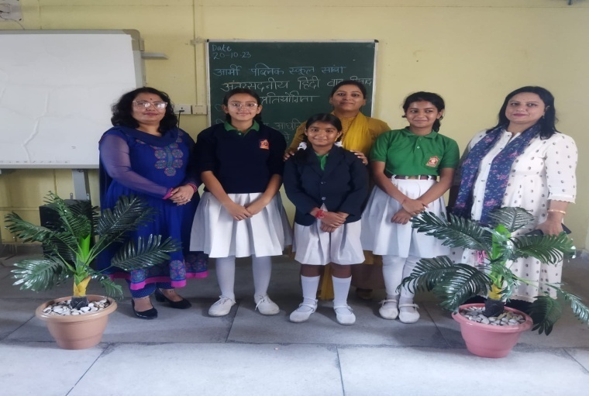

UT LEVEL FENCING COMPETITION (U-19) (OCTOBER 20-21,2023)
UT-Level Fencing Competition (U-19) was organized by Jammu And Kashmir Department of Youth Services and Sports on October 20-21,2023 at MA Stadium Jammu.Two students from APS Samba: Nikhil and Simran (XII)also participated in this tournament.
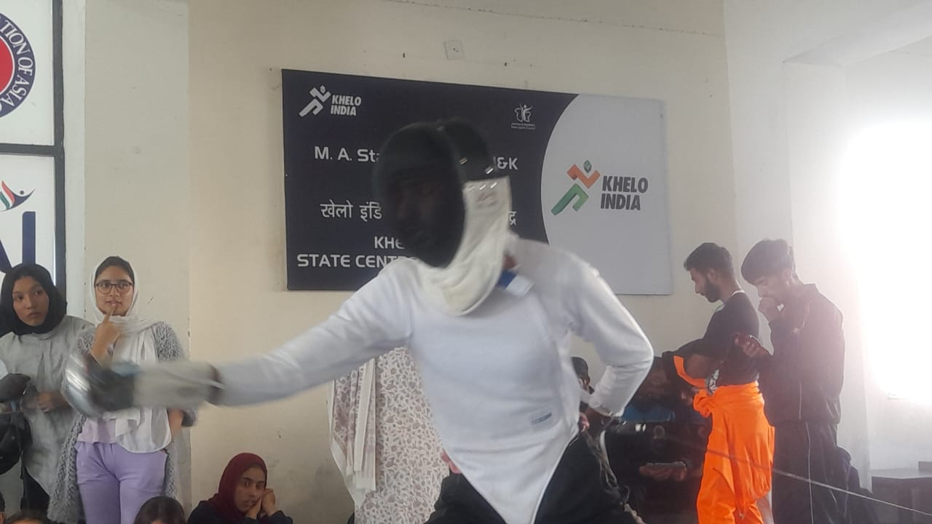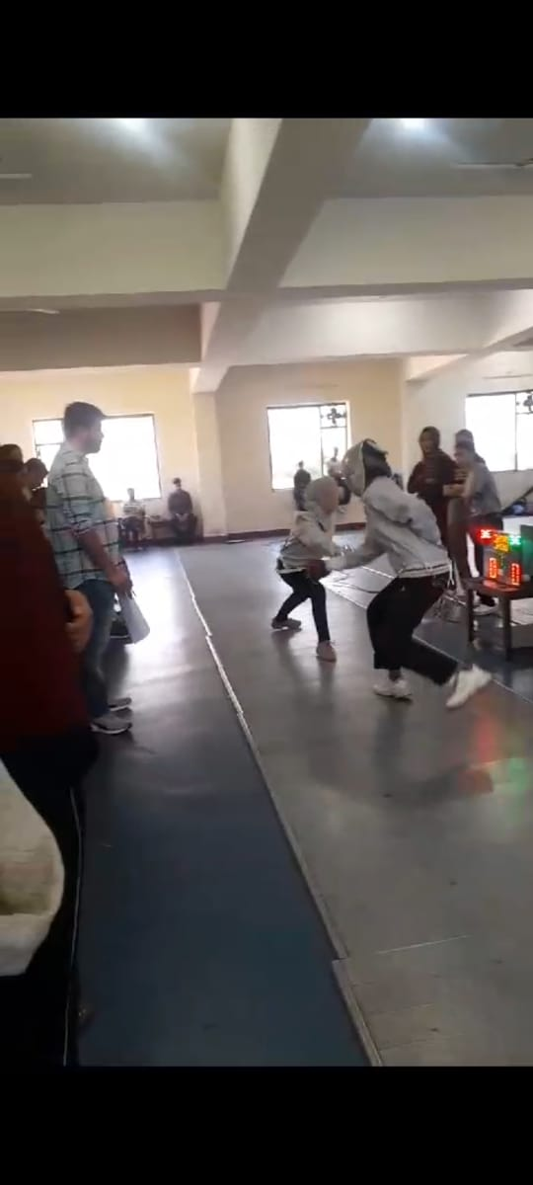

WORKSHOP ON ‘LOVE YOURSELF’ FOR PRIMARY TEACHERS (OCTOBER 21,2023)
A workshop on the topic ‘LOVE YOURSELF’ by Ms Neha Rajput was organized for the Primary teachers on October 21,2023.All the Primary teachers attended the workshop.
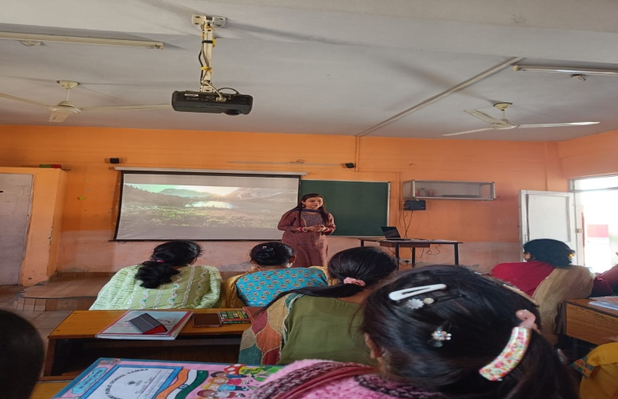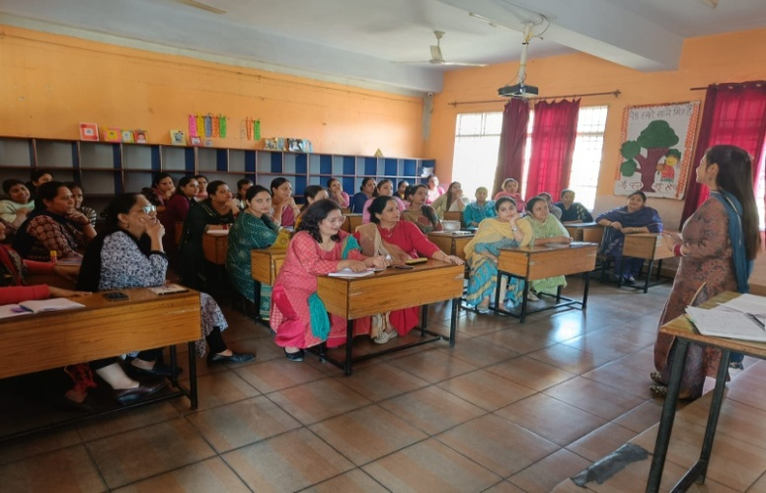
SCHOOL COMMITTEE FOR SQAAF DATA (OCTOBER 21,2023)

A school committee was composed to fill the domains of SQAAF (School Quality Assessment and Assurance Framework (SQAAF) data.The data was submitted by the committee on October 25,2023.

PRE-BOARD – I EXAMS FOR X & XII & HALF YEARLY EXAMS FOR CLASS XI(OCTOBER 26,2023)

Pre-board –I exams for the students of classes X and XII and Half Yearly exams for class XI students commenced from October 26,2023.

8TH SAMBA DISTRICT BADMINTON COMPETITION (OCTOBER 27-29,2023)

8th Samba District Badminton Competition was held at Rani Suchet Indoor Stadium Samba from October 27-29,2023.Students from APS Samba also participated in this competition.A girl from APS Samba named Mrigna of class-IX got gold medal in U-15 single girls tournament.She also got gold medal in U-15 double girls tournament and Second position in U-19 double girls badminton tournament. She is also
selected for UT level competition which will be held in Srinagar.She is felicitated by the Principal, Mr Sanjeev Pradhan in the special morning assembly
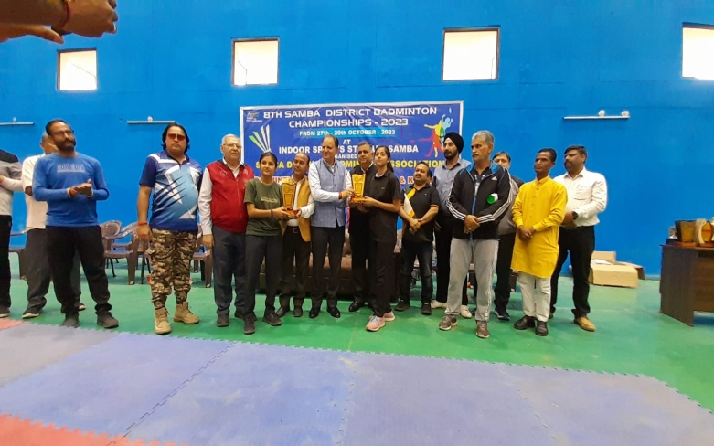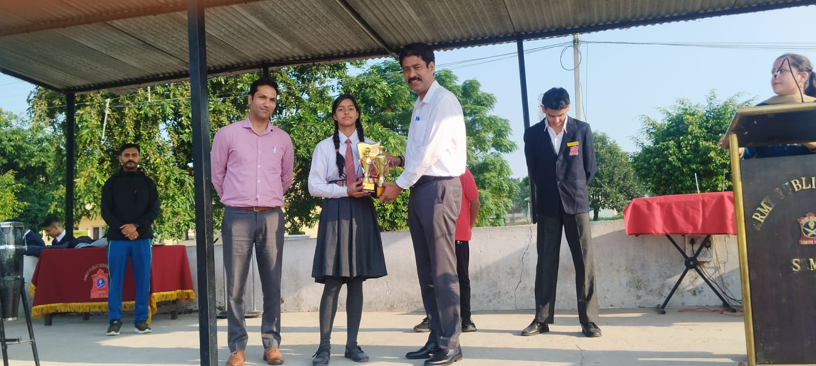

ENGLISH LANGUAGE QUIZ (OCTOBER 28,2023)
To bring young children together to showcase their LINGUISTIC COMPETENCE on a common platform,an inter school English Language and Linguistic Quiz was organized at JKPS Kunjwani Campus under the aegis of Jammu Sahodya Complex on October 28,2023. In this competition,a total of 30 schools participated from all over J & K
Ishaan Pandey of class IX from APS Samba represented APS Samba in this quiz competition and bagged first position.He is also felicitated by the Principal Mr Sanjeev Pradhan in the special morning assembly.

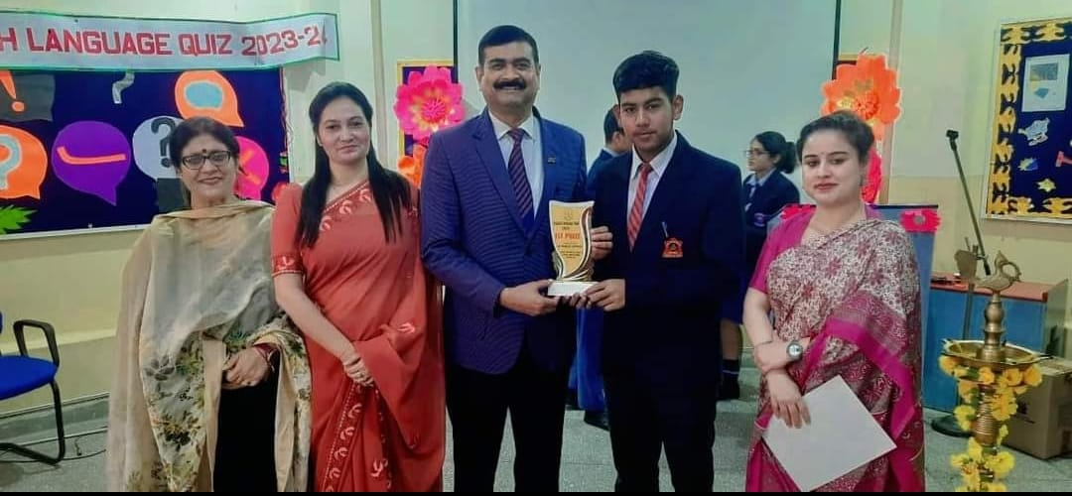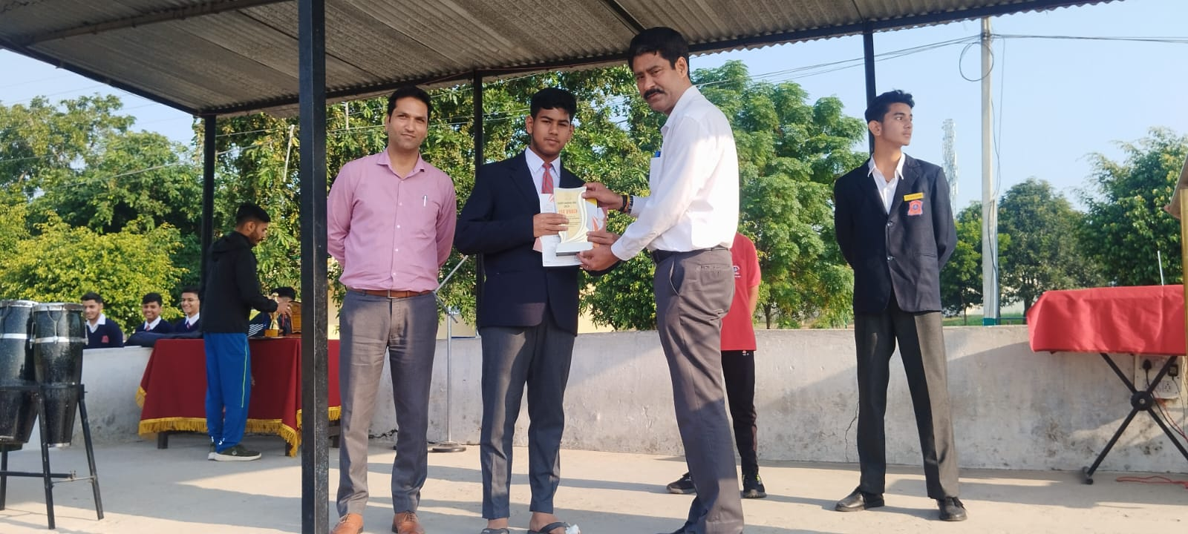

NIAS-ALC SESSION( OCTOBER 28,2023)
Session of NIAS- ALC was conducted on October 28,2023.The topic of discussion for the class was- “Adaptation in plants and animals and study of micro organisms”. Class was fully interactive and students took part in the discussion with great interest.
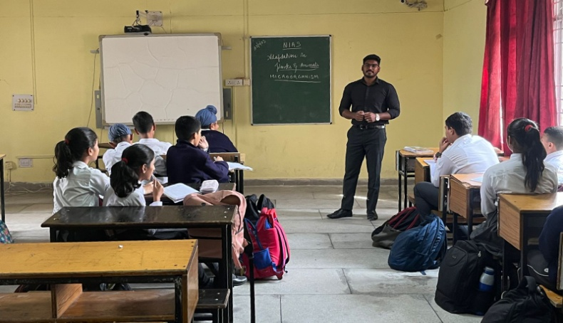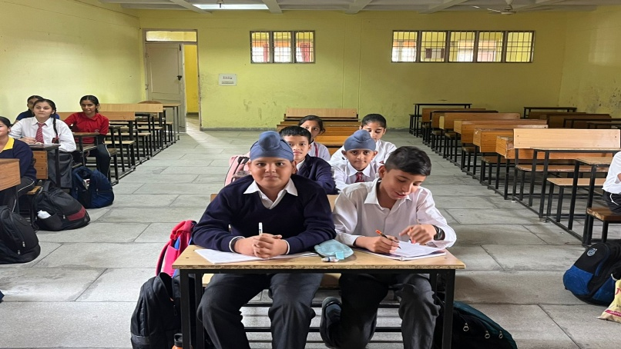

MATHS OLYMPIAD (OCTOBER 31,2023)
To help students to develop critical thinking and problem-solving skills, which are important for success in many
fields, Maths Olympiad was conducted at APS Samba on October 31,2023.In this Olympiad total 415 students from classes II-XII participated.
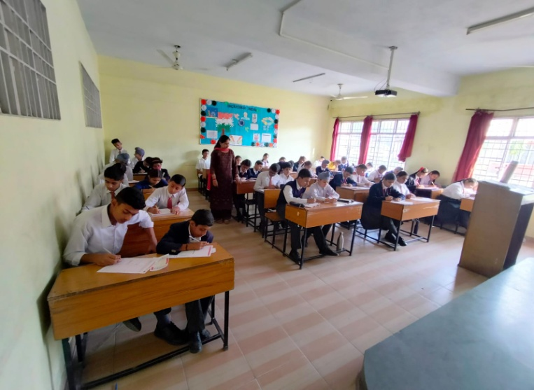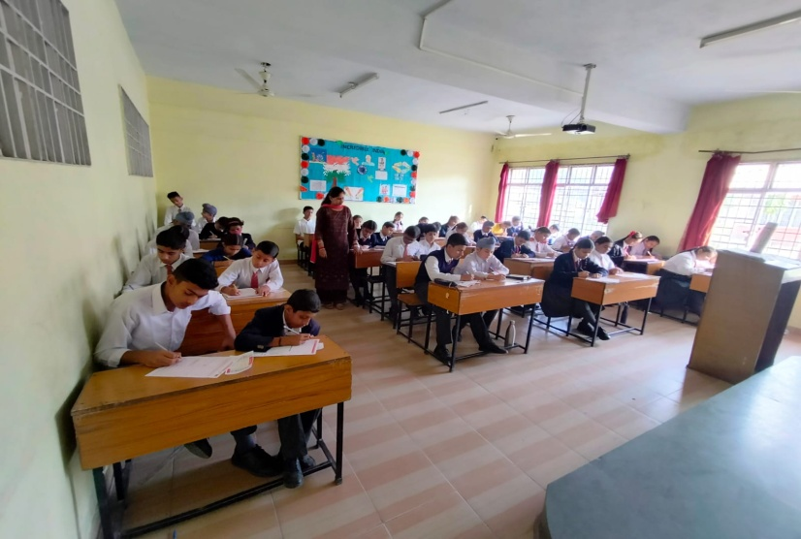

NATIONAL UNITY DAY (RASHTRIYA EKTA DIWAS) CELEBRATION (OCTOBER 31,2023)
As an endeavour to build the bond of oneness and unity and
in line with the celebrations countrywide, Army Public School Samba following the mandate, organized various activities in the school premises on October 31,2023 in order to extend their heartfelt appreciation about the life and the involvement of the great leader,Sardar Patel in the freedom struggle.
On this occasion, a special morning assembly was organized. An impressive speech was delivered by Ms Seema Mirza (TGT) on the life and history of Sardar Vallabhai Patel.
An oath on National unity and solidarity was taken by the teachers and the students where they pledged to work hard in laying a foundation of a unified country. Students of classes V-IX participated in the ‘Run for Unity’ campaign around the campus.The first three students who reached finish point were also felicitated by the Principal,Mr Sanjeev Pradhan.The programme ended with great enthusiasm,with the students promising to work towards the unity of the country.
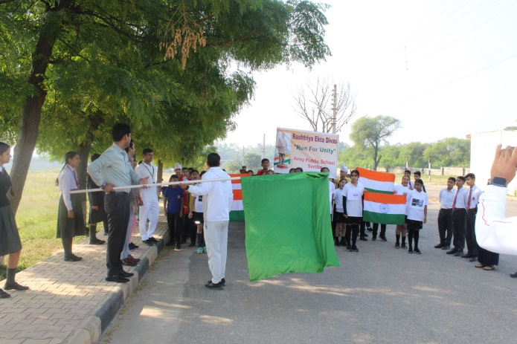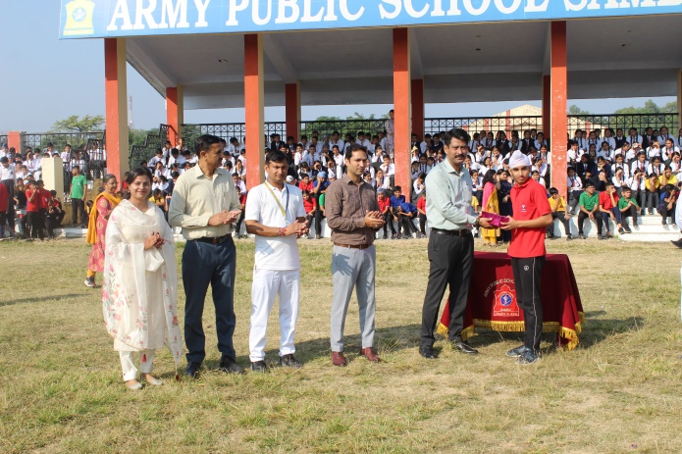

THANK YOU

